**Weather Data Trend Analysis**

### **Summary**

In this project, I analyzed local and global temperature data and compared the temperature trends where I live to overall global temperature trends. Also created a visualization to observe the change in average temperature among several locations in the world.

**Data Extraction and Exploration**

* I extracted the data from source using SQL queries(queries are stated at the end of observations) and then imported the data as CSV format . The data format was also checked and changed to a specific one as required such as temperature data was changed to number from string.
* Google sheet was used to transform the data in desired columns and rows followed by calculation of moving average inspired from our lesson.
* The data availability of our city of interest and also of global average temperature in the same timeline were also considered. Then to compare the trend, I plotted the line chart with a moving average of 5 years in both cases. Below are the questions with answers supported by observations.

**Observations:**

1. **Is your city hotter or cooler on average compared to the global average? Has the difference been consistent over time?**
   1. Yes, San Francisco is usually hotter compared to the global average.
   2. The temperature difference is pretty much consistent showing the maximum temp difference being 6.64 C and minimum 5.37 C with standard deviation of 0.27 C between San Francisco and global average temperature. So really less variance.

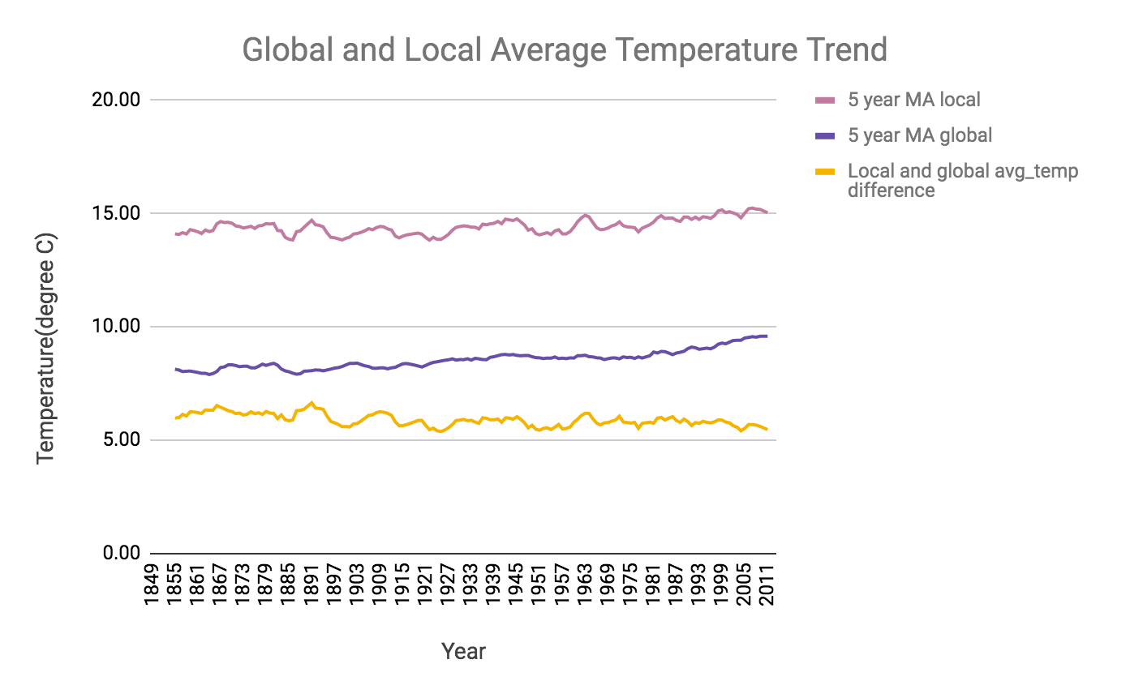

1. **“How do the changes in your city’s temperatures over time compare to the changes in the global average?”**
   1. From the below chart, you can see that average temperature has increased over time. Certainly, the minimum temp is 13.22 C for San Francisco in 1880 and the maximum temperature reached in 2011 as 16.23 C. An increase of 3 C is quite high within 160 years. Global average temperature has also shown a similar rising trend from a minimum of 7.56 C(year 1860) to 9.73 C(year 2005).

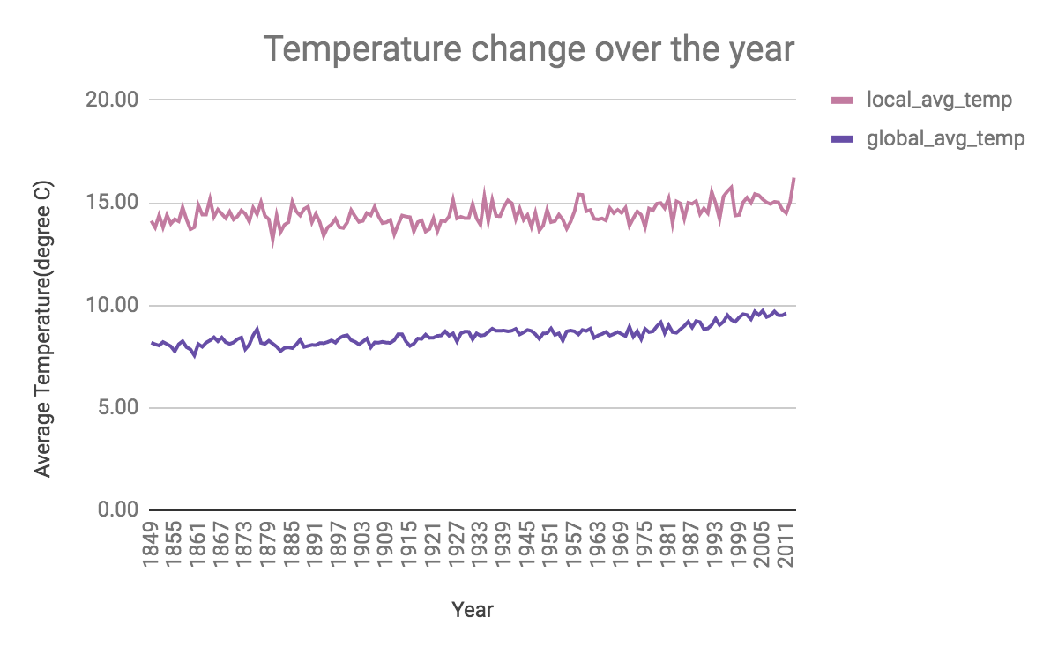

1. **How is the trend among different cities across the globe? What do you learn about them?**
   1. The chart below reflects the temperature profile of big cities around different continents of the world. We certainly can see an increasing trend from the data point we considered to start with i.e. year of 1863 and the ending year of 2011.
   2. There are hotter, moderate and cooler zones where these cities fall into. But the common similarity is the upward trend of average temperature for all of them along the year range of 1863-2011.
   3. Hotter zone includes Dhaka, Singapore, New Delhi, Rio De Janeiro, Singapore and Abu Dhabi. At least 1 degree celsius temperature has risen on average for all of them.
   4. Barcelona is in a comfortable range but also has a similar pattern on average temperature rise.
   5. New York, Milan and London fall into cooler zones following the former groups in case of average temperature rise.
   6. Over the year the average temperature has changed and across the globe, it shows an upward trend with time.

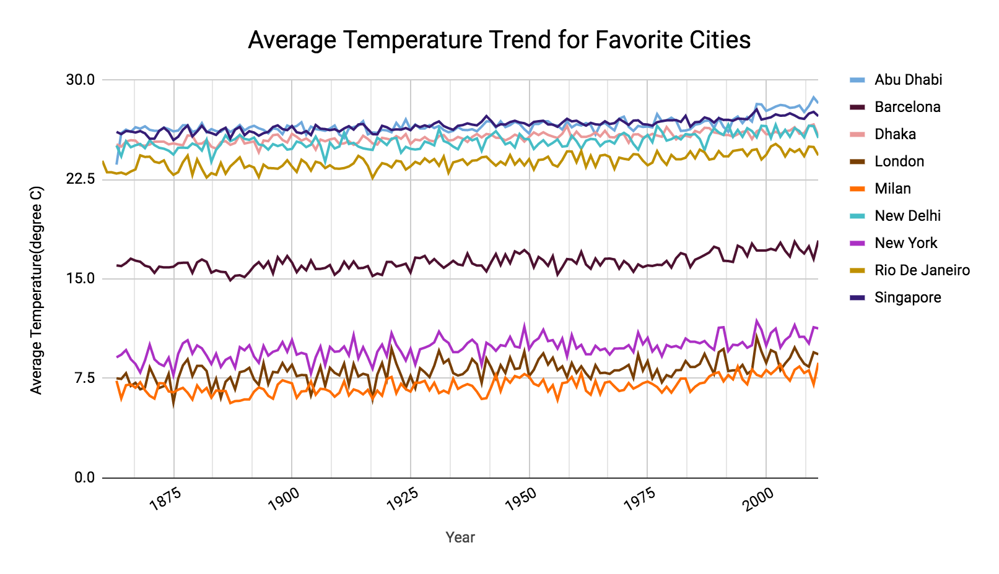**SQL Queries for the questions:**

**Query1. To get local city( San Francisco) average temperature data.**

SELECT *

FROM city_list cl

JOIN city_data cd

ON cl.city = cd.city

WHERE cl.city LIKE 'San Francisco'

**Query 2. To get global data**

SELECT *

FROM global_data

**Query 3. To get different city data across the globe**

SELECT year, city, avg_temp

FROM city_data

WHERE city IN ('London','New Delhi','Dhaka','Singapore','Milan','Abu Dhabi','New York ','Barcelona','Rio De Janeiro') AND year BETWEEN 1860 AND 2011